**Network Between Five Banks**

Before saying what I’ve done here, let me show you how the network looks like after being designed completely.

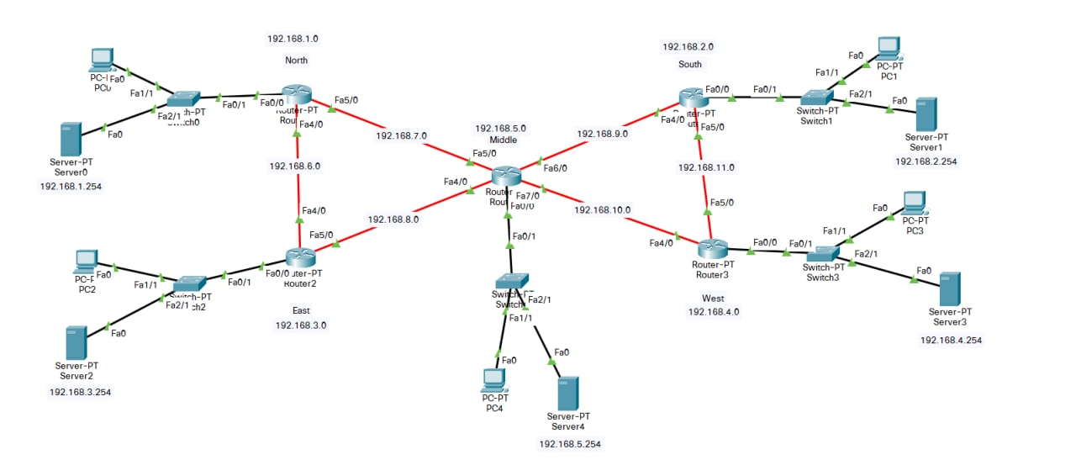

Now here are the steps of designing:

First, I have made the list of IP addresses which will be assigned to each network. Here, this is how it looks like:

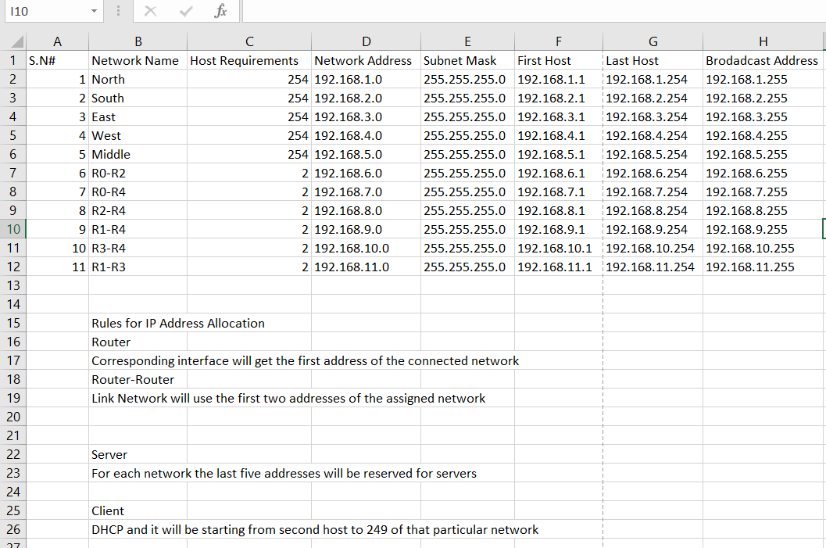

I will attach the pdf file of the above excel file for better view. For designing I have added 5 routers first for 5 networks- North, South, East, West and Middle. Then I added 5 switches, each for each network. Then in every network I added single PC and a single Server. Then, I connected all the devices with each other using the compatible wire. After that, I configured the IP of each routers. Here are the screenshots of router IP configuration of Router 2:

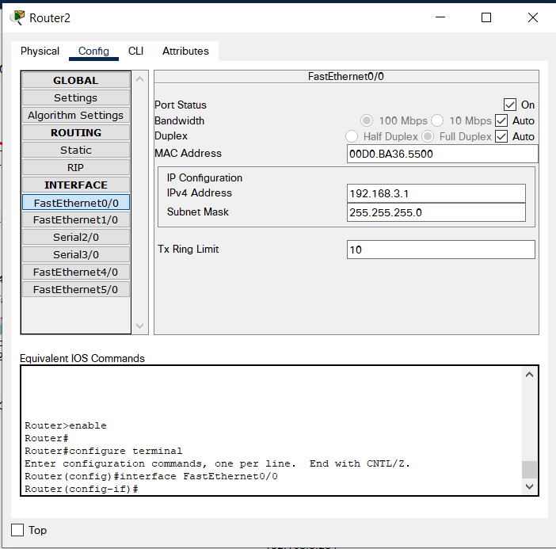 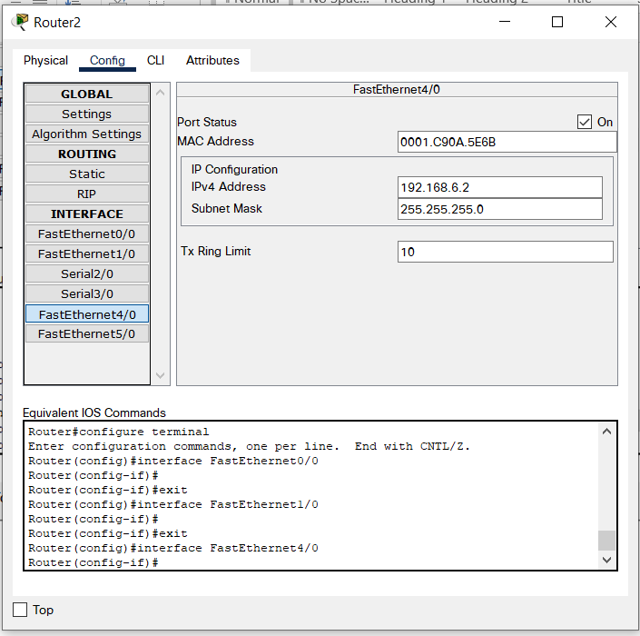

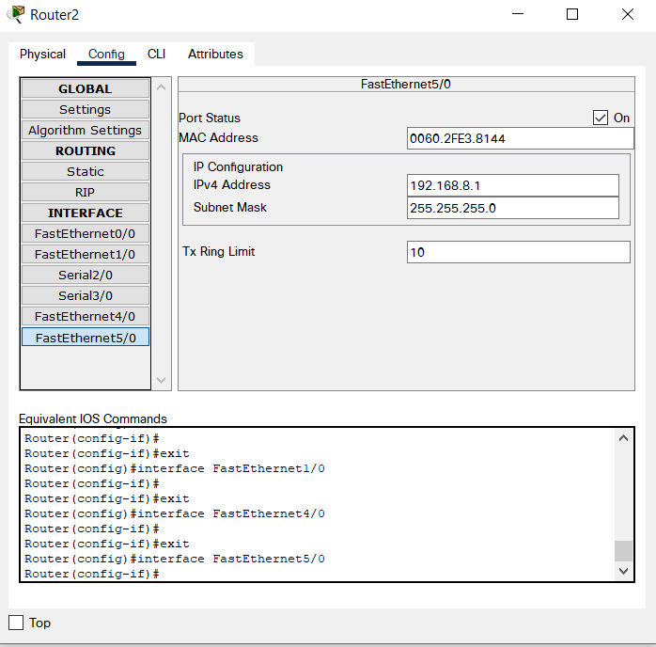

After that, to make sure these networks can route with each other I had to configure the routing address. Here’s a screenshot of that:

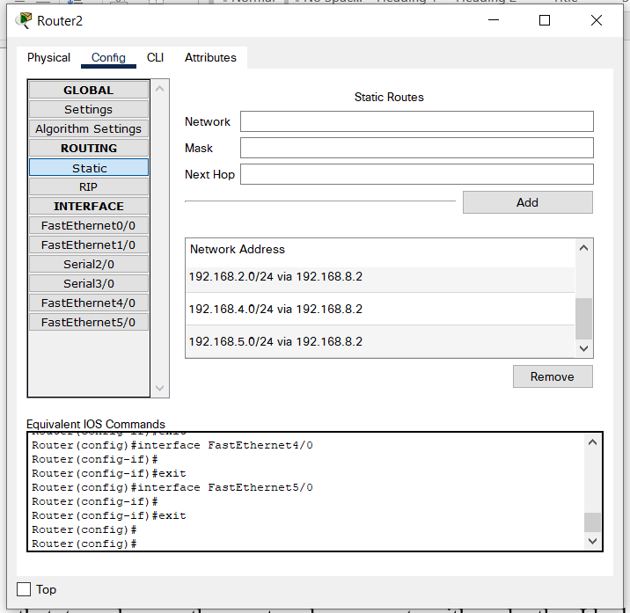

After, it was done, I had to work on the Servers. I made Server-0 the only DNS server which was used as DNS server in all the other servers so that each servers can connect with each other. Here’s the Screenshot of that:

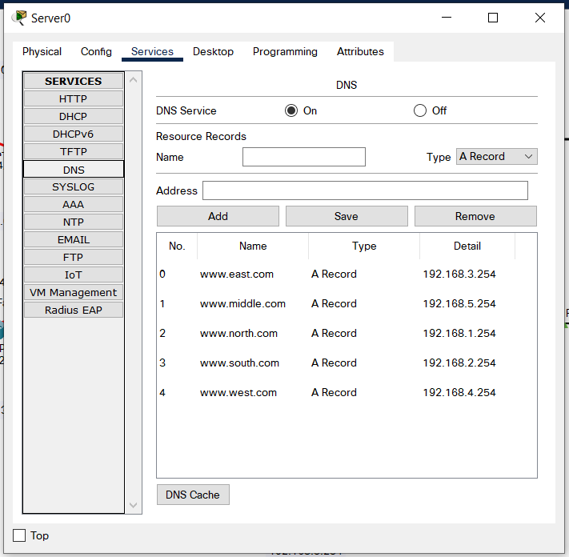

Also, I switched on the DHCP service on all the servers so all the PC can have their IP address automatically by requesting for it. Here’s the screenshot of that:

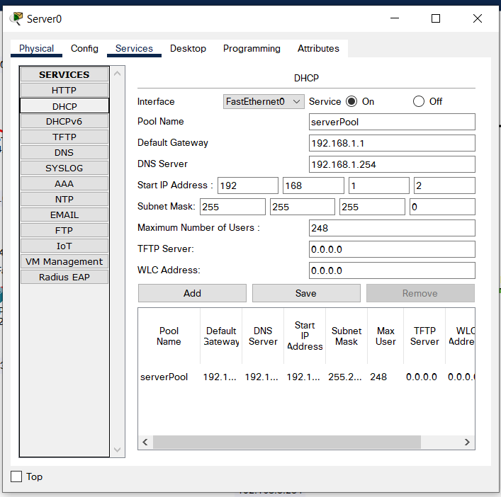

Also I switched on the HTTP/HTTPS service on all the servers and edited the ‘index.html’ file for making it recognizable uniquely.

Now, my connection is done, I can now access into any server/website I created from all the PCs’ as they can successfully communicate with each other. The screenshot of this successful communication can be seen by the ping checking, screenshot of which is given below:

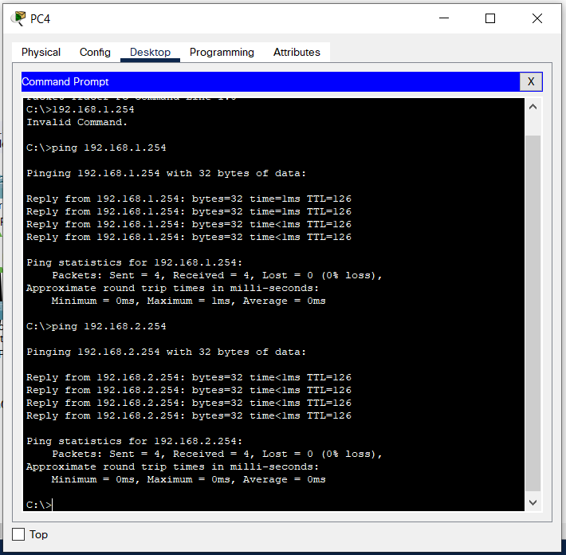

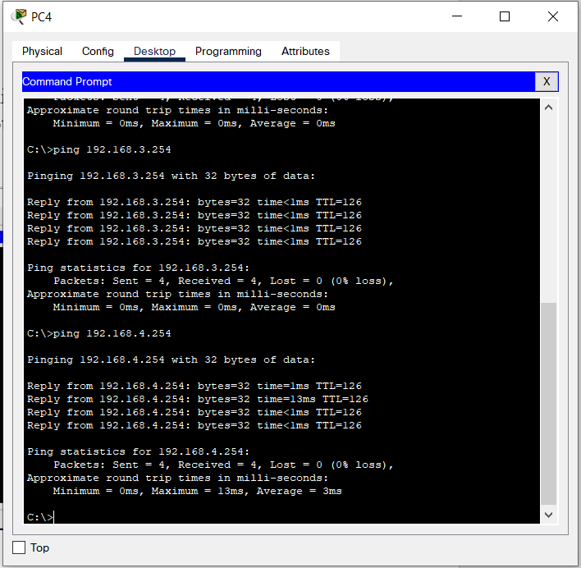

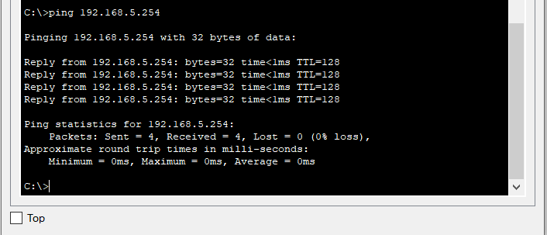

So, as you can see, PC4 can communicate with all the other servers. Now, let’s check out the website for each sites from another PC which is PC1. Screenshots below:

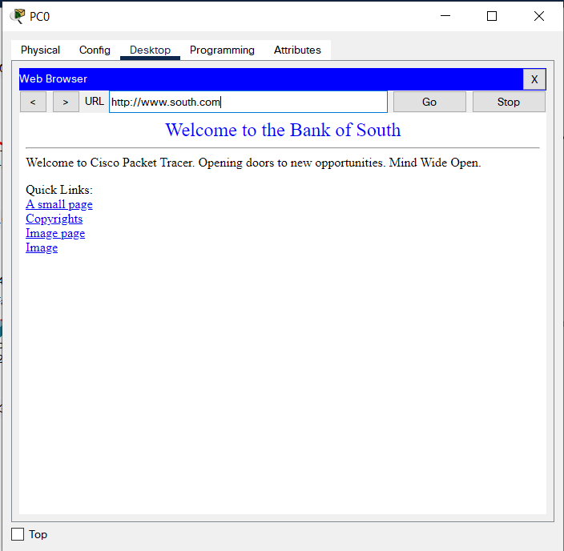

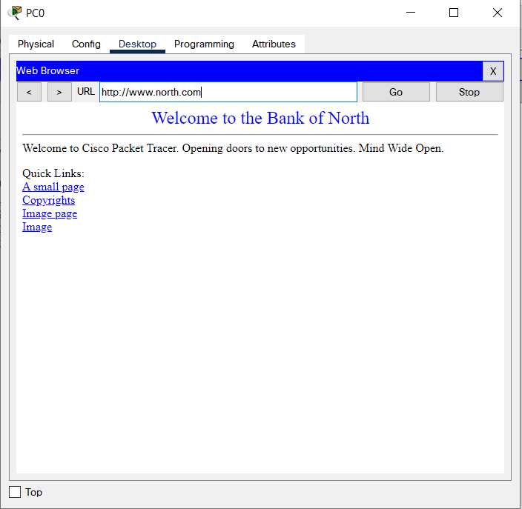

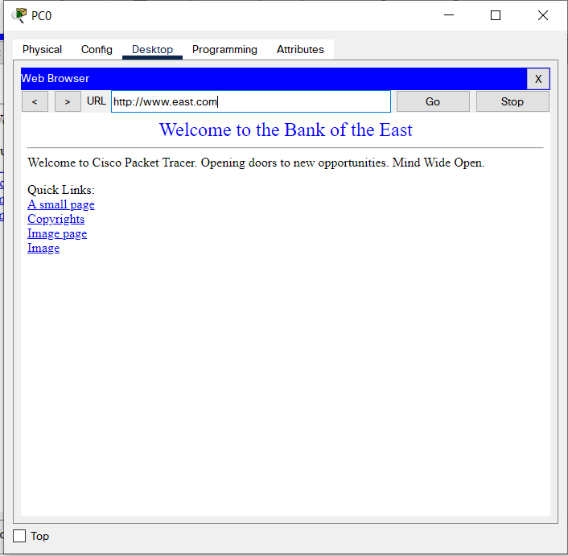

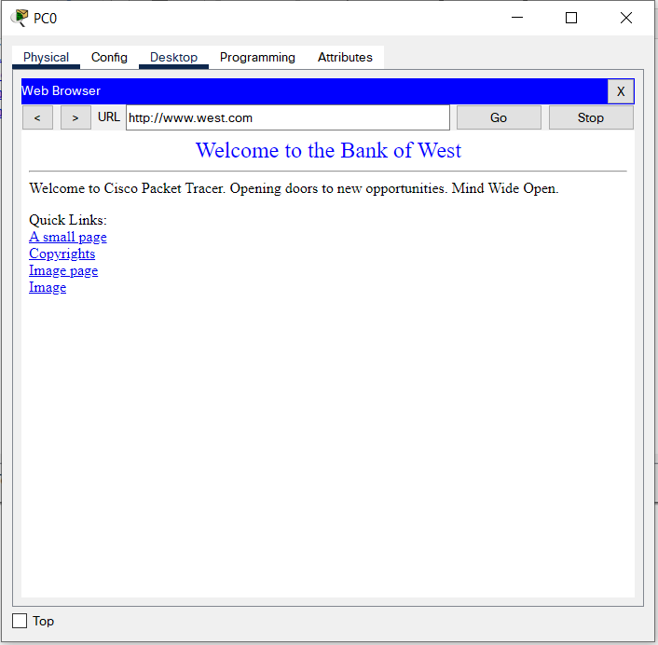

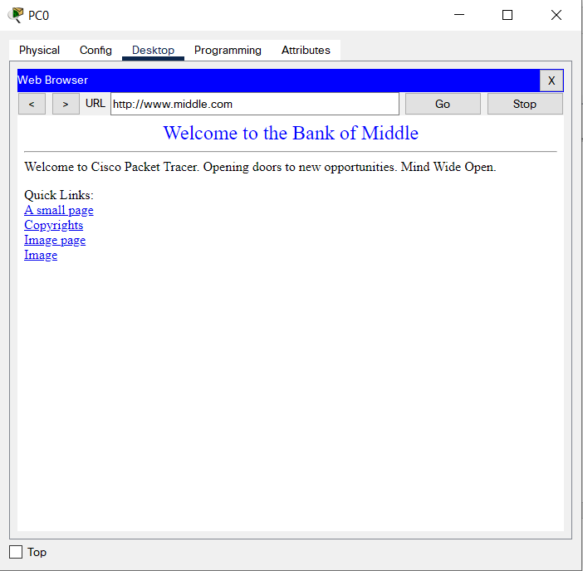

So, this is it, from this I can say my whole network system works perfectly. I will be attaching my Packet Tracer File ase well so that you can check it yourself more thoroughly if needed.